**Citibike Data Analysis and Visualization**

**Data Source:** <https://www.citibikenyc.com/system-data>

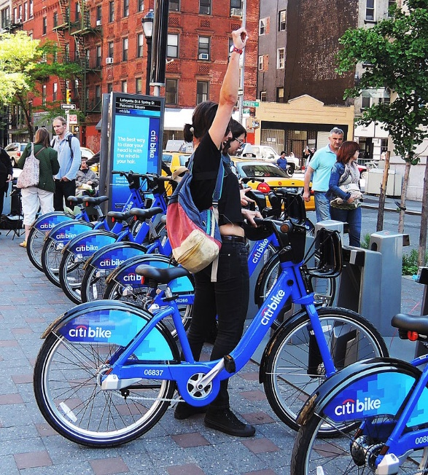

**Dashboard:** <https://public.tableau.com/views/Test_15927811571900/DataAnalysisDashboard?:language=en&:display_count=y&publish=yes&:toolbar=n&:origin=viz_share_link>

**Story:** <https://public.tableau.com/profile/neelam.baxi#!/vizhome/Test_15927811571900/CitibikeAnalysisStory?publish=yes>

**Time period Used for Analysis:** For months January to May, Year 2019 and Year 2020

1. **Impact of COVID-19 Pandemic on citibike usage during the timeframe: January to May 2019 and 2020:**

Total Trips recorded show a downfall by 22.89% from 2019 to 2020.

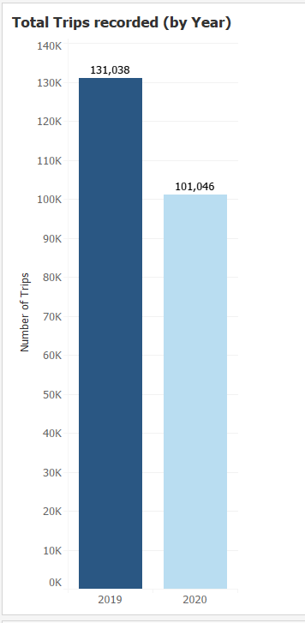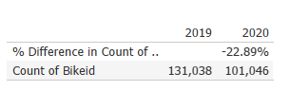

As we see from Number of Trips in 2020 for the months of March, April and May has taken a major hit. This shows that major number of riders were off road and following social distancing orders from the City.

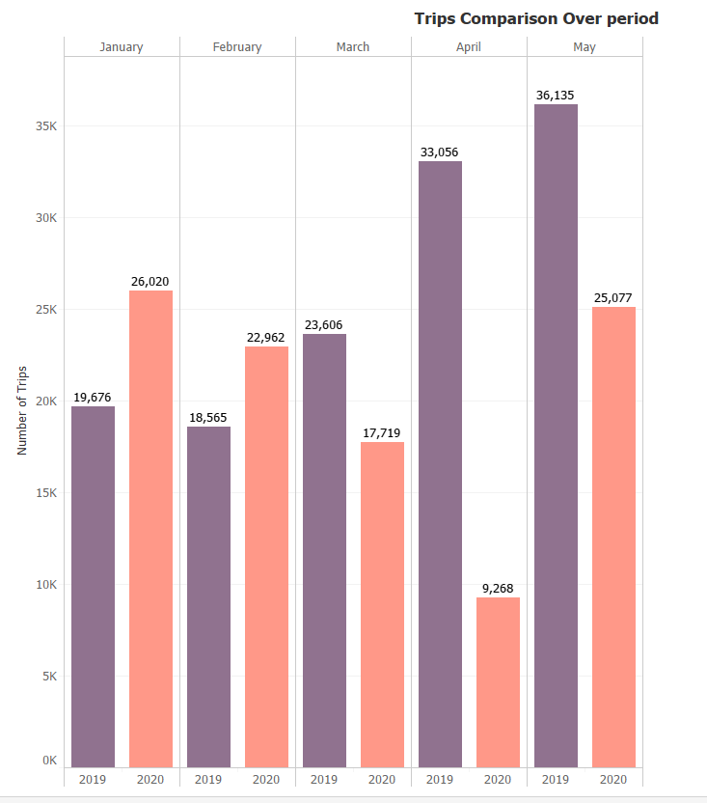

The busiest day of the week for 2019 is Wednesday but it is Sunday for year 2020. This reflects that due to lockdown, riders didn't step out much during the week.

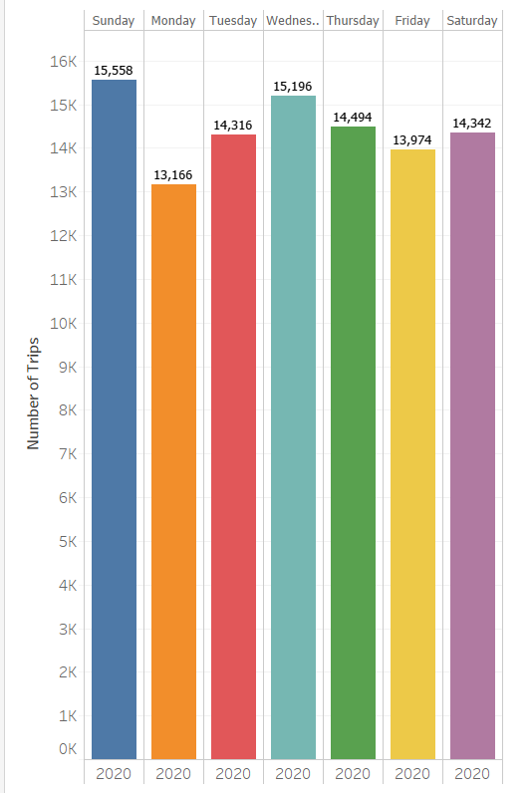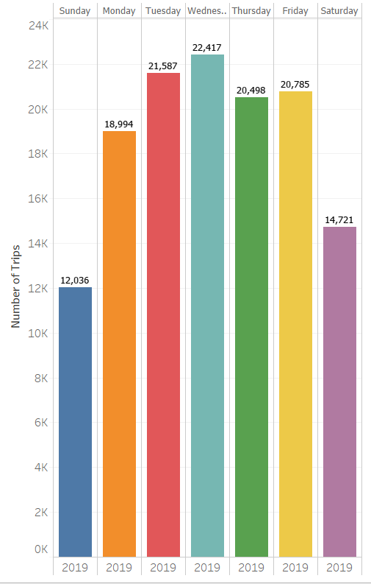

The busiest hour of the day during weekdays changed from 8.00AM in 2019 to 6.00PM in 2020. It may be concluded that riders stepped out post working hours as most people started working from home during this timeframe. Also the weekend hours tend to have changed from 2019 to 2020. In 2020, Weekends seems to have lot of activity compared to 2019.

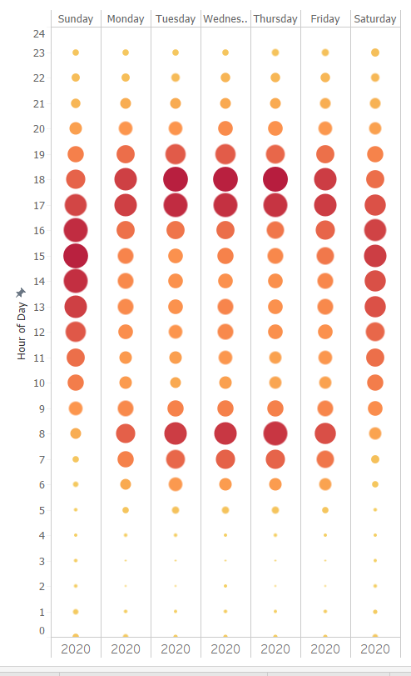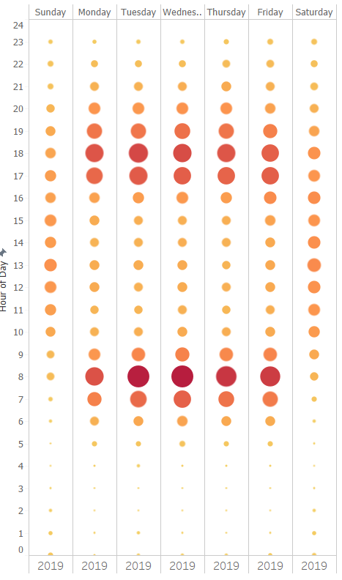

1. Bike Rider Data Analysis:

As we can see here, the maximum trips are by Males. Female riders are only 1/3rd of the total Male riders.

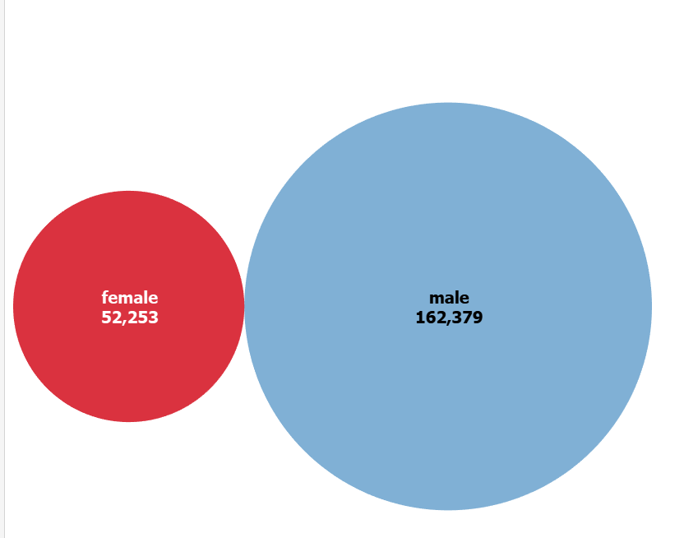

The total trips for Males from 2019 to 2020 was dropped by approximately 30% whereas for females it only dropped by approximately 8%. This reflects that a majority of Males traveling to work by bike didn't step out during the lockdown/stay at home orders.

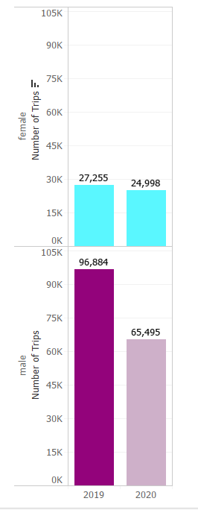

As we see the number of trips dropping from 2019 to 2020, we also see a major drop in the subscriber trips compared to customers. This could be due to stay at home orders and also the increase in customers for the Month of May 2020 could be due to people avoiding public transportation.

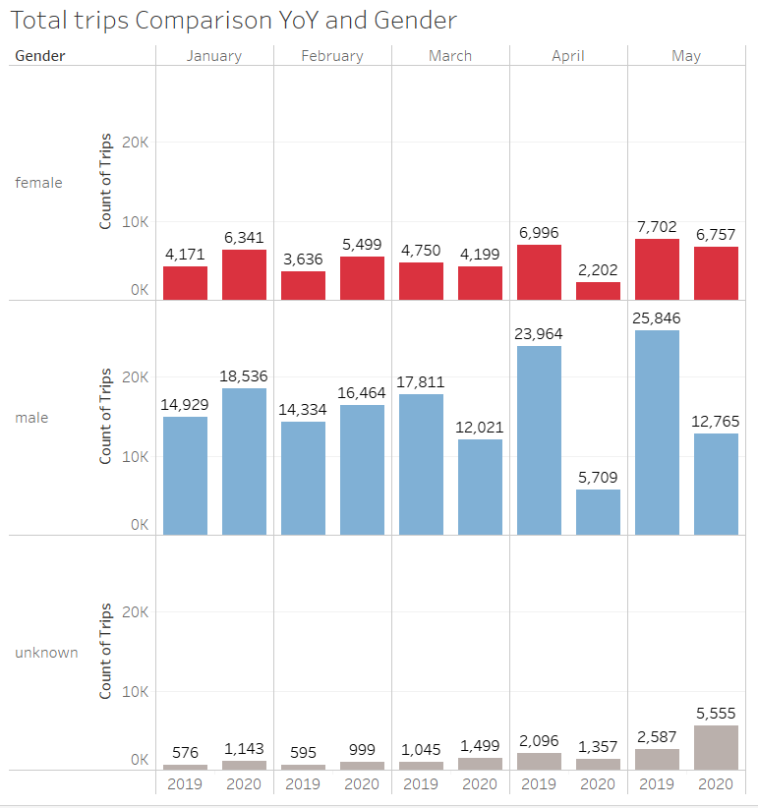

The Bike with highest Average duration (in Mins) has the least count of trips.

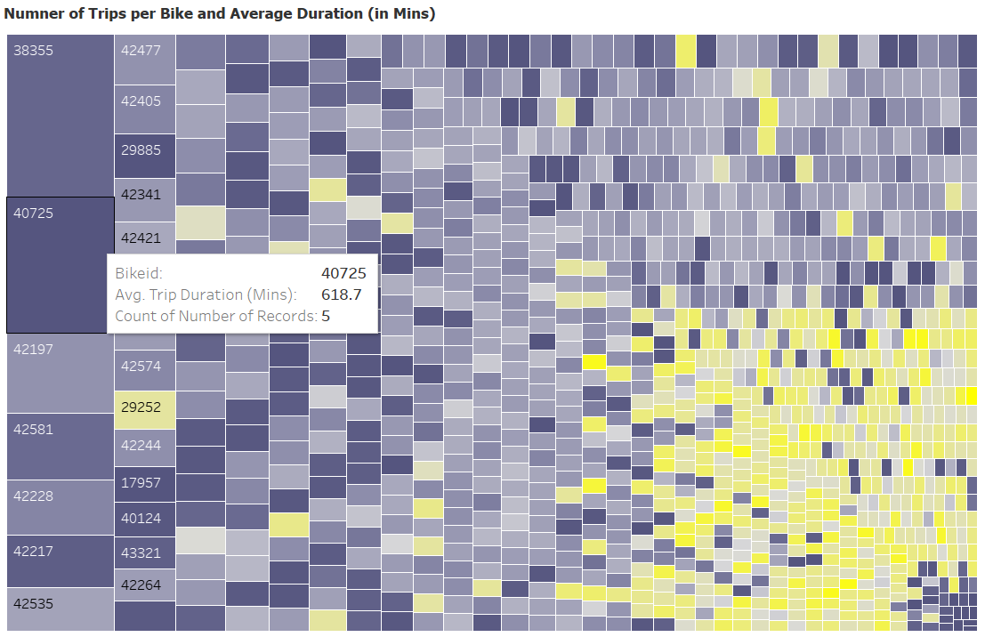

1. Station Data Analysis:

The most popular start and end station for years 2019 and 2020 remain Hamilton Park and Grove St PATH respectively.

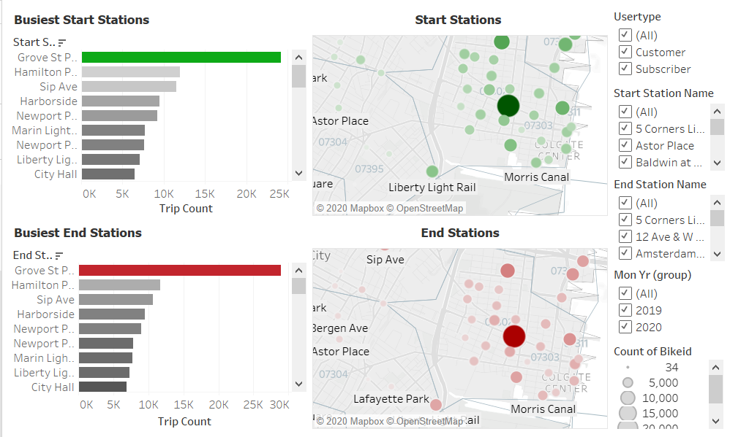

Though we dont see a change in that, we do see the impact on the top stations for years 2019 and 2020. Exchange place station is no longer in top 10 End Stations. It is the closest station to Newport Center train Station that routes through Lower Manhattan and due to lockdown/stay at home orders or social distancing, people preferred to not travel by train.

For 2020:

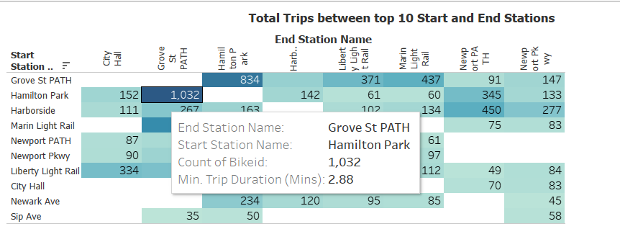

For 2019:

